CSC 134 Spring 2021
Assignment 5
I do NOT debug for students. Solving assignment problems independently is one assessment criteria.

This homework allows students to practice the development of a database using MySQL.
Section 1
Using SQL, create tables according to the given schema shown in Figure 1. Note that this section is exactly the same as the one in Assignment 4. You can use your Assignment 4 directly, or modify your Assignment 4 (if needed).
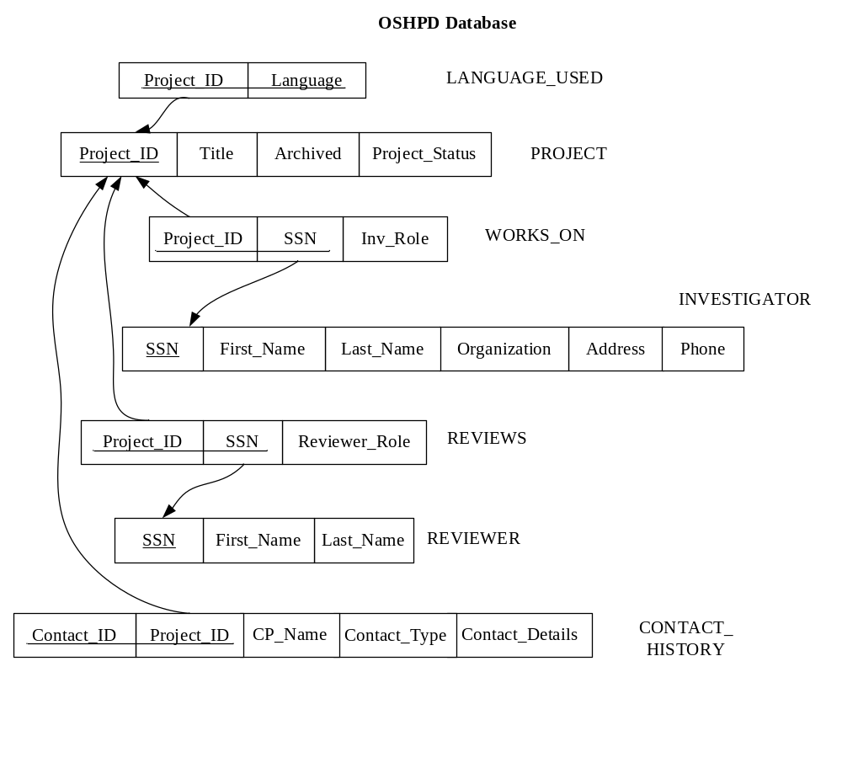

Figure 1 Schema

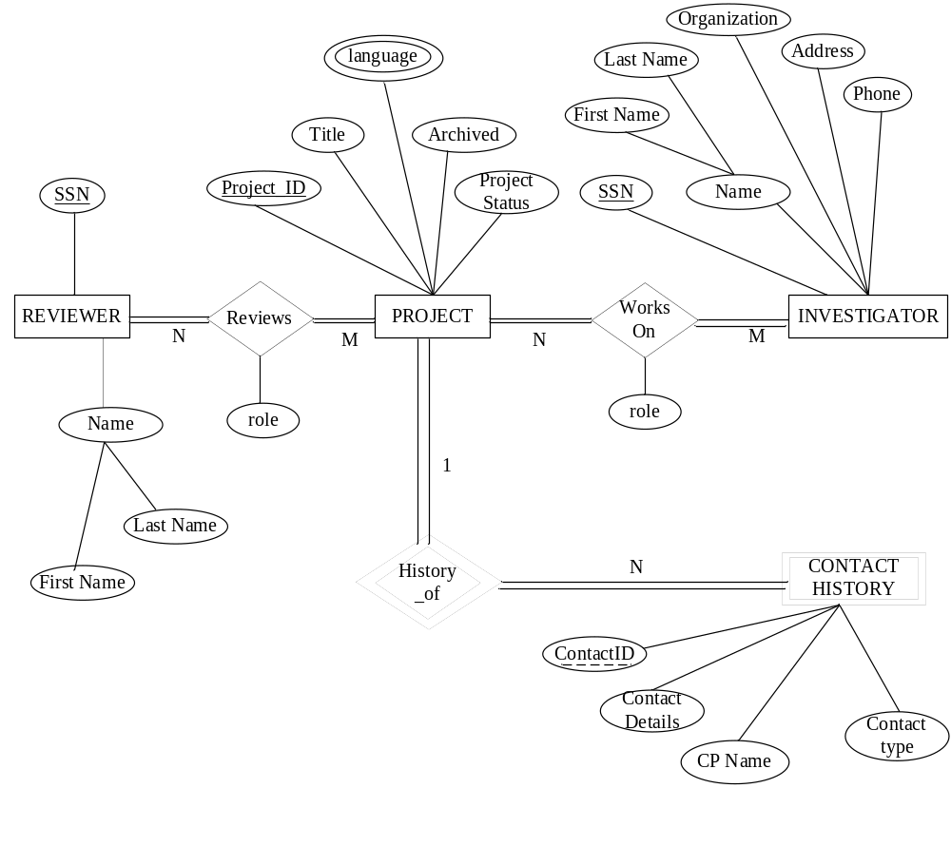

Figure 2 ER Diagram

Section 2
Populate the database. Please check sections 3 for details.
Section 3
Use SQL to specify the following queries. When you populate the database, insert data such that at least one row will be display as the result of running each query.
- Retrieve information about the projects (title, status and whether archived or not) that have an ‘Optional’ reviewer. (hint: Role is “optional”)
- Retrieve the information about the investigators (first name, last name and organization) who have done more than one project.
- Retrieve the information of reviewers (first name and last name), investigators (first name and last name) for the project “Air Quality”.
- Retrieve information about each project and the Investigator of the project. List project ID, title, and SSN and last name of the Investigator. Order the result in ascending order of Project ID.
- Retrieve information about each project and the Principle Investigator of the project. List project ID, title, and SSN and first name of the Principle Investigator. (hint: the role of the investigator is “PI”.)
- Get the project information (project id, title, status and whether archived or not) which has a ‘Co-PI’. (hint: the role of the investigator is “Co-PI”).
- Retrieve all the projects (project id, title) in which “John Smith” serves as a principle investigator.
- Retrieve the reviewers who reviewed more than 2 projects. Please list reviewer’s SSN and number of projects reviewed by the reviewer.
- Retrieve the investigators who serve as “PI” for at least 2 projects. Please list the SSN, last name, and number of projects served as “PI”.
- Retrieved the SSN of all reviewers and all investigators who have “Smith” as the last name.

Section 4
Specify the statements to drop all the tables. Pay attention to the order of the drop statements in order to drop everything successfully. Note that this section is exactly the same as the one in Assignment 4. You can use your assignment 4 directly, or modify your assignment 4 (if needed).

Submission
Submit the following files to Canvas. Note: Submit through any other ways, such as email attachment, will not be graded. Do NOT zip them. Please double check that you submit a correct version and your submission status is “submitted”.
I may randomly select a few students to do demo during my office hours, using your submitted Canvas files.
You must test that the create, insert, drop statements and queries can be executed successfully before your submission.
- *Create table statements (file name must be: 1_create_table.txt)
I will copy everything from this file and execute it. Make sure the tables are listed in the correct order such that I can execute it without any error. For any table that cannot be created, you will lose 40 points, even if the error caused by the incorrect order of creating table. You should have already handled this task in Assignment 4.
Optionally, you can submit a file (optional_screenshot.pdf) to present that you have ran your create table statements and the operations were successful. I still need to run your create table statements to do grading. A demo using your Canvas files may be scheduled if there is any grading disagreement.
- Insert statements to populate database (file name must be: 2_populate_db.txt)
0 will be given to each non-executable insert statement
- Queries (file name must be: 3_query.txt)
Note that if the create table statements do not work properly, your query may not be executable even it is correct.
Less than 30% of the points will be given to each non-executable query, even if the query is specified correctly, but cannot be executed because of incorrect create table statements.
- *Statements to drop all tables (file name must be: 4_drop_all.txt)
0 will be given to each non-executable drop statement.
- An output file showing query results (file name must be: 5_output.pdf). In this file, for each query, you must:
  - Include the number and query description (e.g Query 1: Retrieve information ….)
  - Your SQL query (e.g. select… from…)
  - The result of running this query (screen shots is required).
Note: 1* and 4* can be the same as the ones that you submitted in Assignment 4, however, you have to resubmit them in this assignment.

